7.1.35 Editors - 3D View - Header - Grease Pencil - Vertex Paint mode - Active Layer menu
Active Layer Menu 1
New Layer 1

Active Layer Menu
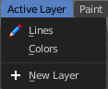
Set and show the active grease pencil layer. The layer with the pencil is the active layer for drawing.

New Layer
Add a new draw layer.

